**IDAHO INDUSTRIAL COMMISSION**

**IC-36 INSTRUCTIONS**

Please visit [www.iic.idaho.gov/find-a-form/](http://www.iic.idaho.gov/find-a-form/) to download our current IC-36 excel workbook template.

* If you **WILL USE** the online portal, either sheet within the template is acceptable for upload as an EXCEL file.
* If you **WILL NOT USE** the portal, the **“Printable”** template and **signature** is **required.**

The portal is accessed **only** through receiving an **e-mail reminder** from the Idaho Industrial Commission which contains a **link** and a **key**. The link and key is **unique** to each report.

* Successful submissions through the portal will return a summarized copy of the report by e-mail to both the preparer and/or certifier.
* First reminders will be within a week after report quarter end.
* If you wish to use the portal and have **NOT** received this e-mail within the first week, please contact [wca@iic.idaho.gov](mailto:wca@iic.idaho.gov).

Every **FATAL, PERMANENT TOTAL AND PERMANENT PARTIAL** claim on which **ANY** unpaid awards or reserves are payable by your company, must be entered on this form and carried forward on subsequent reports until paid out and reported with an unpaid balance of zero.

New cases will be entered as they are determined and carried forward on the next report.   
Be sure to disregard all Temporary Total cases.

**This report must be completed by the Insurance Company even if you have NONE (“Zero Report”) and submitted to the IIC by the end of the month following the end of each calendar quarter.**

**Template Guidance & Definitions**

|  |  |
| --- | --- |
| **HEADING:** | Print name of insurer or self-insured employer, year and select calendar ending quarter. **(Printable Template only)** |
| **COLUMN 1:** | **JURISDICTION CLAIM NUMBER** |
| The jurisdiction claim number is returned by the Industrial Commission when a claim is reported through the EDI. **It is 10 digits long.** | |
| **COLUMN 2:** | **DATE OF INJURY** |
| Please use the **MM.DD.YYYY** format with a period, dash (-), or forward slash (/) separators. | |
| **COLUMN 3:** | **EMPLOYEE'S NAME** |
| Employee's name as reported on First Report of Injury (**FROI**) | |
| **COLUMN 4:** | **TYPE OF CLAIM** |
| Enter in this column the kind of case; i.e., FATAL (**FTL**), PERMANENT TOTAL (**PTD**), OR PERMANENT PARTIAL (**PPI/PPD**). (Use Abbreviations)  Any claims with indications of PPI, PTD, or FTL are considered to be required on this report if there are **any** **unpaid balances.** | |

|  |  |
| --- | --- |
| **COLUMN 5:** | **TOTAL AWARD** |
| Include **TOTAL** compensation awarded (aka “initial reserves”) for Fatal, Permanent Total and Permanent Partial claims. The total award should include **the total medical, indemnity, and legal costs related to the entire claim**.  This amount does not change for the purpose of this report. If any changes occur in subsequent reporting periods, please include the affected amount in the **“Adjustments” (Column 8)**. | |
| **COLUMN 6:** | **COMPENSATION THIS REPORT PAID** |
| Enter the amount paid on each claim since the last report was filed. **Cannot be negative amount.** | |
| **COLUMN 7:** | **TOTAL COMPENSATION PAID** |
| Enter the total amount paid on the award, including amount shown in **“Compensation This Report Paid”** **(Column 6)**. This is a cumulative amount of what has been paid, including the amount for the current reporting period. **This amount cannot be negative.** | |
| **COLUMN 8:** | **ADJUSTMENT** |
| Make all adjustments for changes of conditions, remarriage, deaths, errors, reimbursements, overpayments, etc. in this column. Please net all adjustments, this is a cumulative amount of all changes affecting the award, reserves, payments, etc.   If adjustments *are* made, then the following formula must be true:   |  |  |  |  | | --- | --- | --- | --- | |  | (Column 5) | **“Total Award”** | *$100,000* | | *less* | (Column 7) | **“Total Comp Paid”** | *$50,000* | | *plus* | (Column 8) | **“Adjustments”** | *$25,000* | | *equals* | (Column 9) | **“Unpaid Balance”** | *$75,000* | |  |  |  |  | | |
| **COLUMN 9:** | **UNPAID BALANCE (AUTO CALC)** |
| This will show the balance due on each claim at the end of this quarter.  **This amount cannot be a negative.**  This field is **auto-calculated** on both the provided excel worksheet and the portal. | |

**IF NOT USING THE PORTAL, THE “PRINTABLE” TEMPLATE MUST BE SIGNED DIRECTLY BY A CORPORATE OFFICER OF THE SURETY**

[**SEE IIC ADMIN RULE 17.01.01.302.01.K (2023)**](https://adminrules.idaho.gov/rules/current/17/index.html)

|  |  |  |
| --- | --- | --- |
| **(PREFERRED)** | **SUBMIT BY E-MAIL TO: WCA@iic.idaho.gov** | |
| **OR MAIL TO:** | **Mailing Address** | **Physical Address (overnight)** |
|  | Idaho Industrial Commission  Fiscal Section  PO Box 83720  Boise, ID 83720-0041 | Idaho Industrial Commission  Fiscal Section  11321 W. Chinden Blvd, Bldg #2  Boise, ID 83714 |

If you have any questions, please contact one of the Workers’ Compensation Financial Analysts:

|  |  |  |  |  |
| --- | --- | --- | --- | --- |
| For company names beginning with letter: | **A-L** | contact Alan Pace | at (208) 334-6083 or | [alan.pace@iic.idaho.gov](mailto:alan.pace@iic.idaho.gov) |
| **M-Z** | contact Eric Summers | at (208) 334-6026 or | [eric.summers@iic.idaho.gov](mailto:eric.summers@iic.idaho.gov) |

**IC-36 PORTAL DETAILED INSTRUCTIONS**

# Verify Stage: Access Portal from E-Mail

Following each quarter end, the designated IC-36 preparer for your company (as reported on your **contacts report**) will receive an e-mail reminder from the Idaho Industrial Commission (@iic.idaho.gov) which will contain a link to your portal form, and a verification key to access it.

The message may look like the following:

After clicking on **“here”** you will be brought to our portal, to enter your access (validation) key from your e-mail. Then click on **“Next”** to enter the **“Information Entry”** stage of the portal.

# Information Entry Stage

You will begin by entering the total number of claims on your report, the portal will self adjust depending on the quantity of claims you have to report.

## IF 0 CLAIMS

The portal will pre-fill the remainder of the zero report.   
Click **“Next”** to advance to the **“Review & Submit”** stage.

## IF 1 TO 3 CLAIMS

The portal will ask you to add claim details, one at a time.   
A button will reveal to allow you to **‘Add IC-36 Claim’**.

On clicking **‘Add IC-36 Claim’** the following pop-up will appear:

The **“UNPAID BALANCE”** for the claim is calculated by the portal.

Multiple claims will be summed by the portal on this page. The total **“UNPAID BALANCE”** for the whole report will be calculated and viewable on the next page after hitting **“Next”** for the **“Review and Submit”** stage.

### Note: If a claim detail needs to be deleted or edited

Click on the dropdown menu **“v”** within the claim to the right of the unpaid balance:

### Note: If the popup does not load for “Add IC-36 Claim”,

Clicking within the area should refresh and correctly load the popup.

## IF 4 OR MORE CLAIMS

The portal will ask you to:

1. **Manually** enter the column **TOTAL AMOUNTS** from your report
2. **Upload the required excel worksheet** of the report using or substantially following our IC-36 report template provided at [www.iic.idaho.gov/find-a-form/](http://www.iic.idaho.gov/find-a-form/)

The total **“Unpaid Balance”** will be calculated by the portal, and viewable after hitting **“Next”** to advance to the **“Review & Submit”** stage.

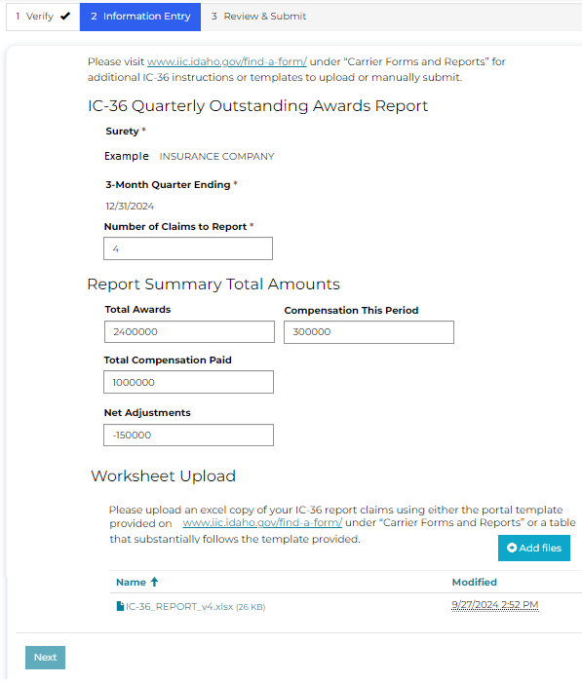

# Review & Submit Stage

Review your total **“Unpaid Balance”** on this stage for accuracy. **A corporate officer from the insurer must be the one to certify this report.**

If the preparer is **not** a corporate officer, the corporate officer will receive an e-mail **request to certify** with a link and key where they can review the prepared information, and **CERTIFY** this report.

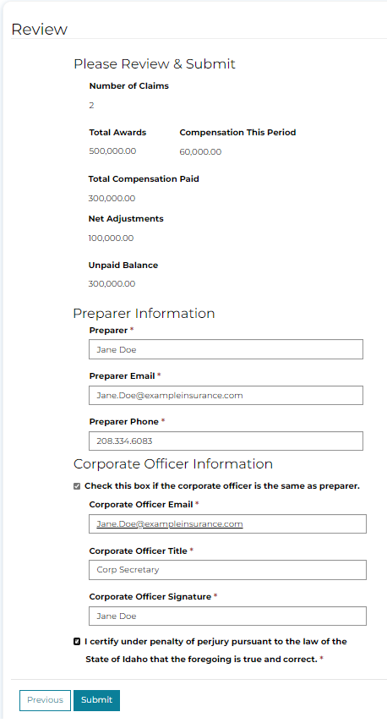

# Confirm E-Mail Receipt

When the preparer submits an IC-36 Report through the portal:

1. **WITHOUT** certification
   1. The preparer will receive an e-mail summarizing the report, with (UNCERTIFIED) prefixed in the subject line
   2. The Corporate Officer will receive a similar e-mail with (REQUEST) prefixed in the subject line, and a **link** and **key** to **CERTIFY** the report
   3. **After** the corporate officer **CERTIFIES** the report, **both** individuals will receive an e-mail with (CERTIFIED) prefixed in the subject line, and a summary of the report.
2. **WITH** certification *(checks box for “if corporate officer is the same as the preparer”)*
   1. The individual will receive an e-mail summary of the report submitted, with (CERTIFIED) prefixed in the subject line.